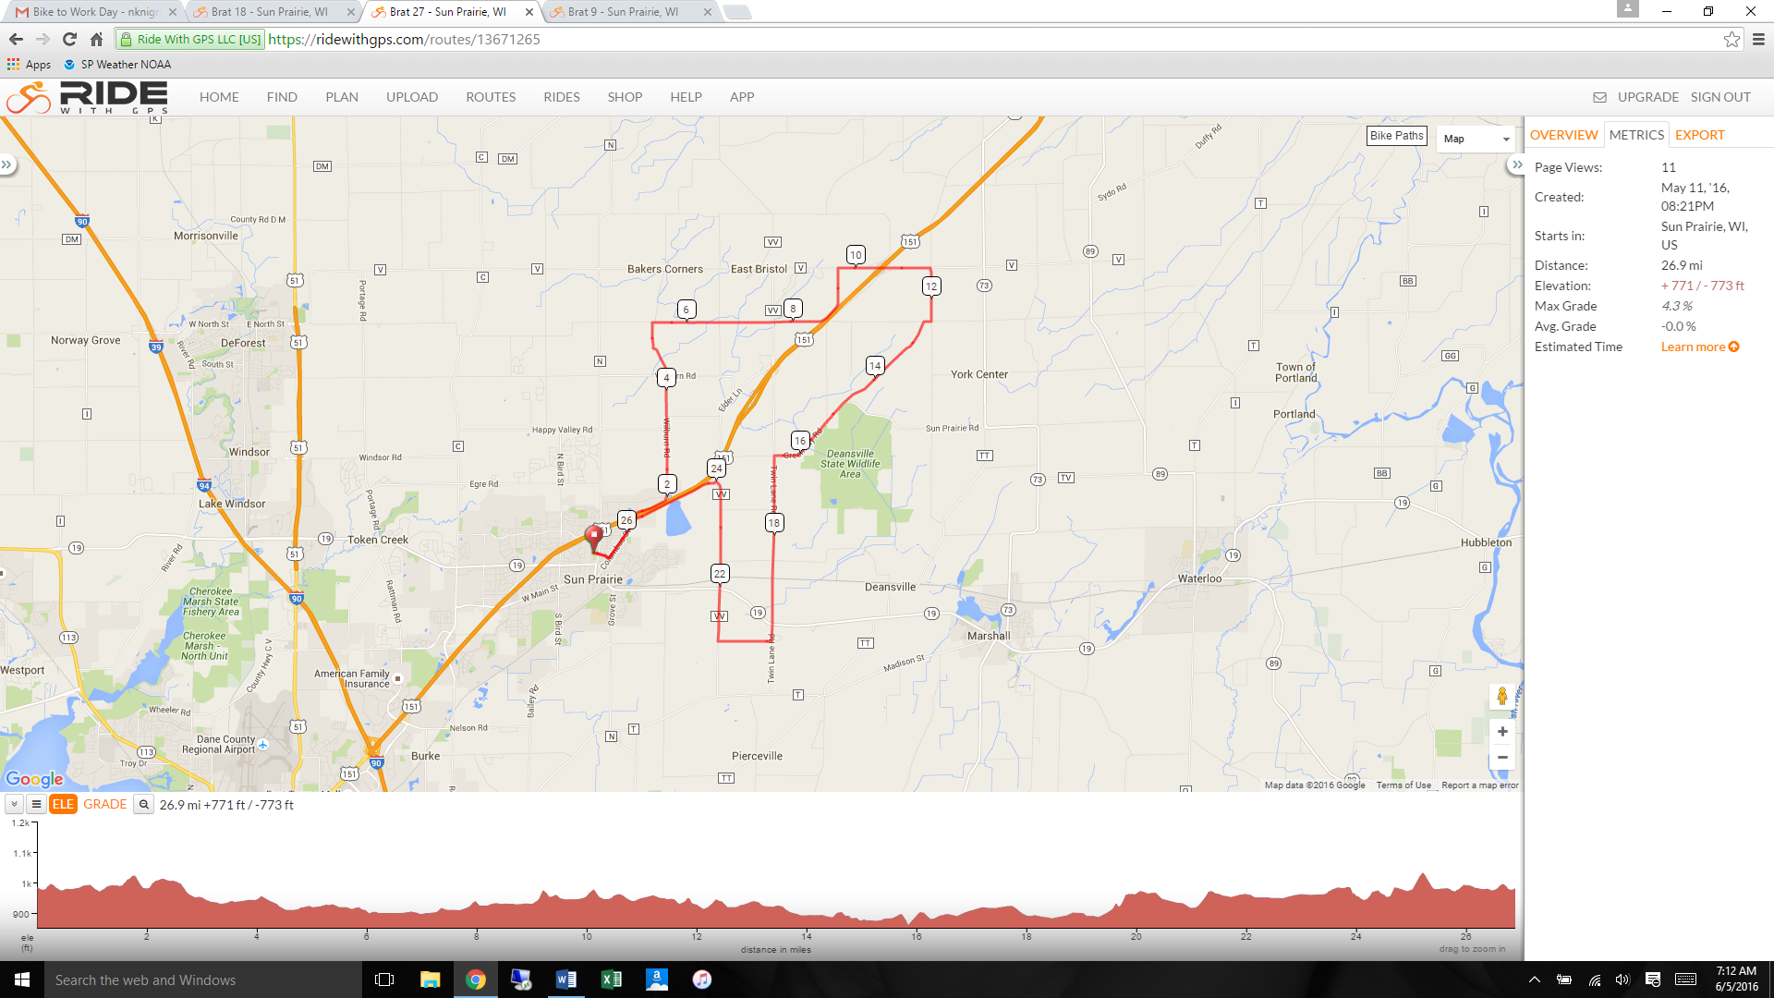

Stone Quarry

Mueller

**27-Mile**: From V:

RIGHT on Deansville

Then RIGHT on Mueller

Then quick LEFT on Janisch

Mueller

Twin Lane

**18-Mile** RIGHT on Berlin

**27-Mile**: Right on Yelk (first right after Hwy 19)

Janisch (turns into Greenway)

V

**18-Mile** RIGHT on VV

**9-Mile** RIGHT on ELDER

**9-Mile** RIGHT on BRANCH

START: Columbus (N) to Wilburn (under 151)